**.Net Technology (01CE0602)**

**Department of Computer Engineering**

**6th Semester**

**Lab Manual**

**(Year: 2022-23)**

**Index**

|  |  |  |  |
| --- | --- | --- | --- |
| **Lab** | **Programs** | **Date** | **Signature** |
| 1 | a. Write a C# Program to print “Hello World”.  b. Write a C# Program to add 2 Numbers.  c. Write a C# Program to find maximum of 2 Numbers.  d. Write a C# Program to generate electricity bill using Else-If ladder.  e. Write a C# Program to find the sum of first N numbers. |  |  |
| 2 | a. Write a C# Program to check a number is Palindrome or not.  b. Write a C# Program to generate Fibonacci series up to N Numbers.  c. Write a C# program to create a calculator using Switch Case.  d. Write a C# Program to print a given array in reverse.  e. Create a simple C# code for the following:  55555  4444  333  22  1 |  |  |
| 3 | a. Write a C# program find area of Circle, Rectangle and Square using Polymorphism.  b. Consider a class Information that has data members as Name, Surname and Contact number. Let Employee and Student class inherits Information class with its own other information such as Students Semester or Employee Salary. Implement a system using Method Overriding to take input from the user for all the information and display proper output.  c. Consider a class Apartment that has data members as Apartment number and balcony type. Implement a system that has 3 classes as 1bhk, 2bhk and 3bhk such that it does not allow to create any other classes above 3bhk. Also implement inheritance in such a way that 1bhk will have Rectangular Balcony and all other flats have Rounded Balcony (Use Sealed Class). |  |  |
| 4 | a. Apply Interface to find the area of Square, Rectangle and Circle. Display proper output.  b. Create two interfaces Icredit and Idebit with methods deposit and withdraw respectively. Create a class Account that inherits interface such that it provides the functionality of Crediting some amount and withdrawing some amount. Use Proper Variables and display output accordingly.  c. Demonstrate a calculator using delegate. |  |  |
| 5 | a. Write a C# Console based application to create following table using ADO. Net.  b. Write a C# Console based application to display all the records of a table.   |  |  |  |  |  | | --- | --- | --- | --- | --- | | Emp_id | Name | Designation | Department | Salary | | 1 | Raj | Manager | Sales | 35000 | | 2 | Priya | Manager | HR | 30000 | | 3 | Manoj | Driver | Transport | 15000 | | 4 | Aakash | Executive | Finance | 85000 | |  |  |
| 6 | a. Write a C# Console based application to implement a functionality to insert a new record in the table  b. Write a C# Console based application to implement a functionality to display specific record from the table  Use Above Table as per Lab 5. |  |  |
| 7 | a. Create a Simple Calculator using Windows Forms.  b. Create a Windows Forms that will change the background color, forecolor and styling of the given text. |  |  |
| 8 | a. Create a Windows Form that will move the data from one tool to other tool (Usage of ComboBox and ListBox)  b. Create a GUI for the following: Consider textbox(txt1) for Full Name, textbox(txt2) for enrolment, textbox(txt3) for email, textbox(txt4) for mobile, combobox(cmb1) for Semester, radiobutton(rd1,rd2) for Gender and datetimepicker(dtp1) for birthdate and button(btn1). Write backend code for taking input of each and display all values in pop-up box with proper message on button (btn1) click. |  |  |
| 9 | a. Create a GUI for the following: Consider textbox(txt1) for Full Name, textbox(txt2) for enrolment, textbox(txt3) for email, textbox(txt4) for mobile, textArea(txtarea1) for Address, textbox(txt5) for City, combobox(cmb1) for Semester, radiobutton(rd1,rd2) for Gender and datetimepicker(dtp1) for birthdate, checkbox(ck1) for Agree to Register and button(btn1). Write backend code for taking input of each control and if Agree checkbox is checked, then store all these data in the database. Show Pop-Up message: “Registration Successful”. |  |  |
| 10 | a. Write a Windows based application to create following table using ADO. Net.  b. Write a C# Windows based application to display all the records of a table.  Use Above Table as per Lab 5. |  |  |
| 11 | a. Write a C# Windows based application to implement a functionality to insert a new record in the table  b. Write a C# Windows based application to implement a functionality to display specific record from the table.  Use Above Table as per Lab 5. |  |  |
| 12 | a. Write a C# Windows based application to implement a functionality to insert a new record in the table  b. Write a C# Windows based application to implement a functionality to display specific record from the table.  Use Above Table as per Lab 5. |  |  |
| 13 | a. Write a C# code to generate 3 different lines of different colors.  b. Write a C# code to generate 4 different lines of Multicolor Rectangle.  c. Write a C# code to generate 2 ellipses on a windows form. |  |  |
| 14 | a. Write XAML code for the following: Consider textbox(txt1) for First Number, textbox(txt2) for Second Number, textbox(txt3) for Answer, and 4 buttons (btn1,btn2,btn3,btn4) for Addition, Subtraction, Multiplication and Division respectively. Write backend code for taking input of 2 numbers and display relevant output as per button click.  b. Write XAML code for the following: Consider textbox(txt1) for Full Name, textbox(txt2) for enrolment, textbox(txt3) for email, textbox(txt4) for mobile, combobox(cmb1) for Semester, radiobutton(rd1,rd2) for Gender and datetimepicker(dtp1) for birthdate and button(btn1). Write backend code for taking input of each and display all values in pop-up box with proper message on button (btn1) click. |  |  |

**LAB - 1**

**Program 1: Write a C# Program to print “Hello World”.**

**Code:**

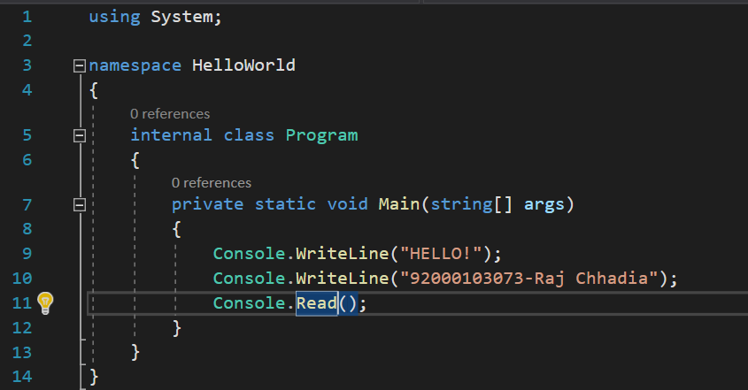

**Output:**

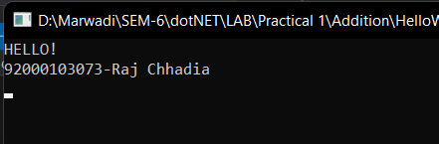

**Program 2: Write a C# Program to add 2 Numbers.**

**Code:**

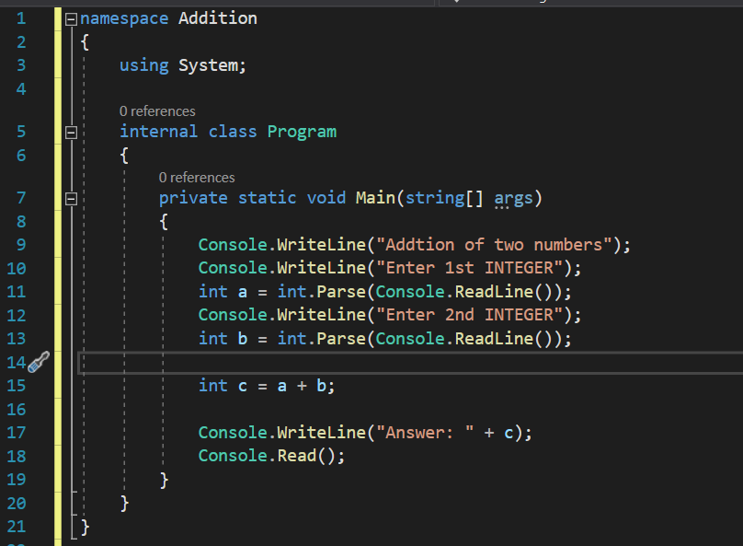

**Output:**

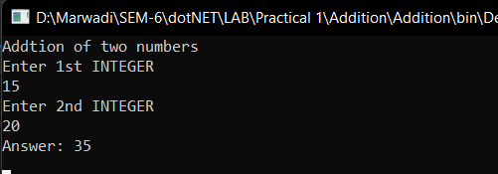

**Program 3: Write a C# Program to find maximum of 2 Numbers.**

**Code:**

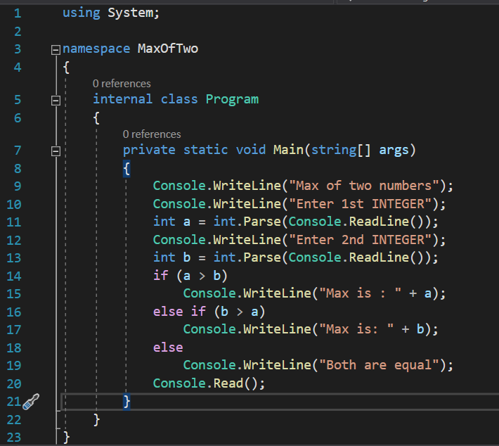

**Output:**

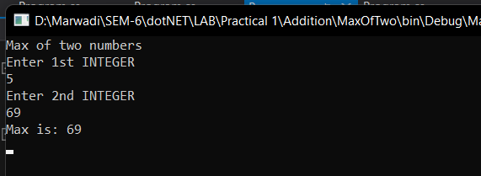

**Program 4: Write a C# Program to generate electricity bill using Else-If ladder**

**Code:**

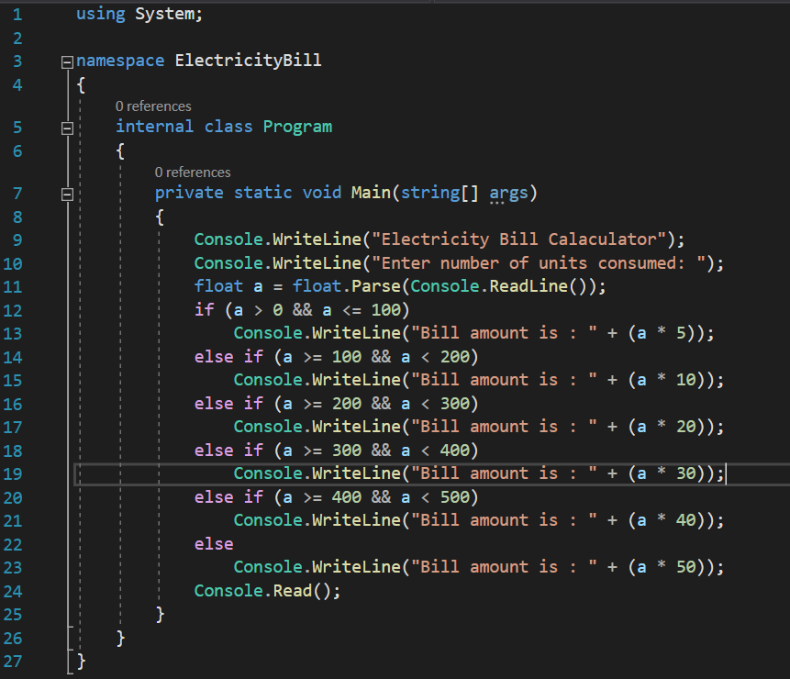

**Output:**

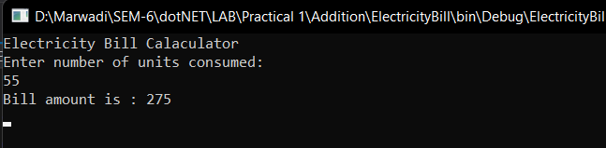

**Program 5: Write a C# Program to find the sum of first N numbers.**

**Code:**

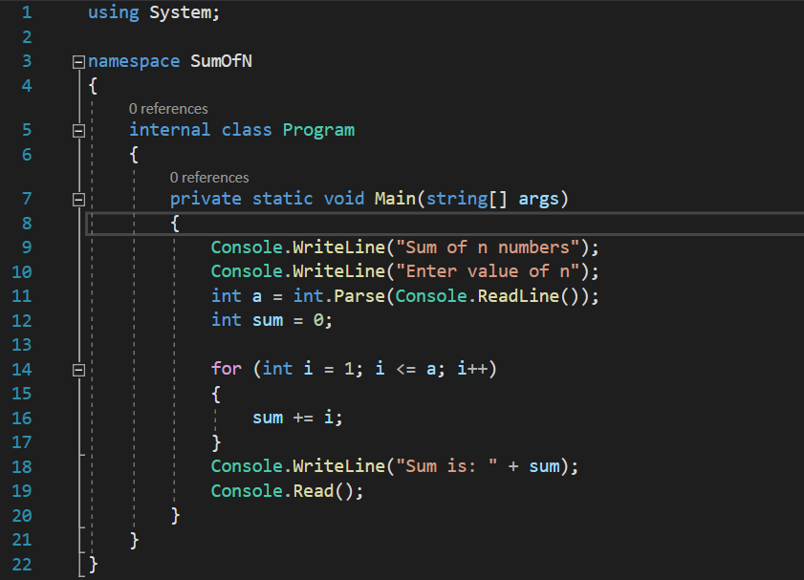

**Output:**

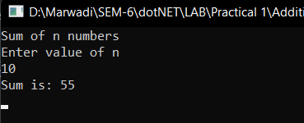

**LAB - 2**

**Program 1: Write a C# Program to check a number is Palindrome or not.**

**Code:**

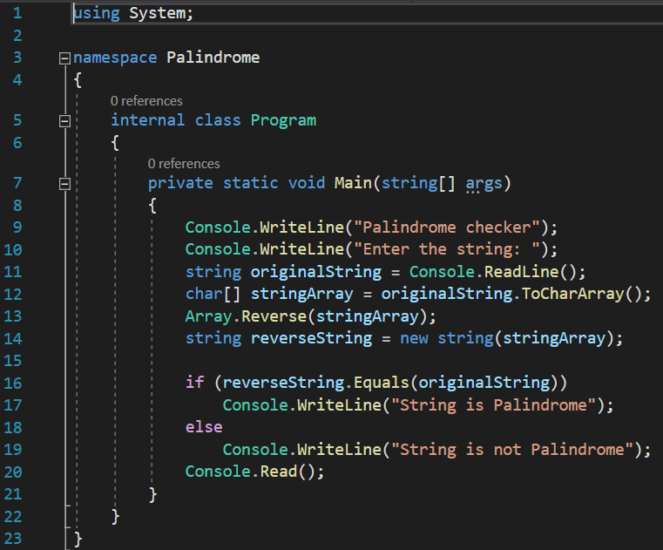

**Output:**

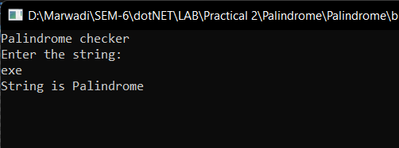

**Program 2: Write a C# Program to generate Fibonacci series up to N Numbers.**

**Code:**

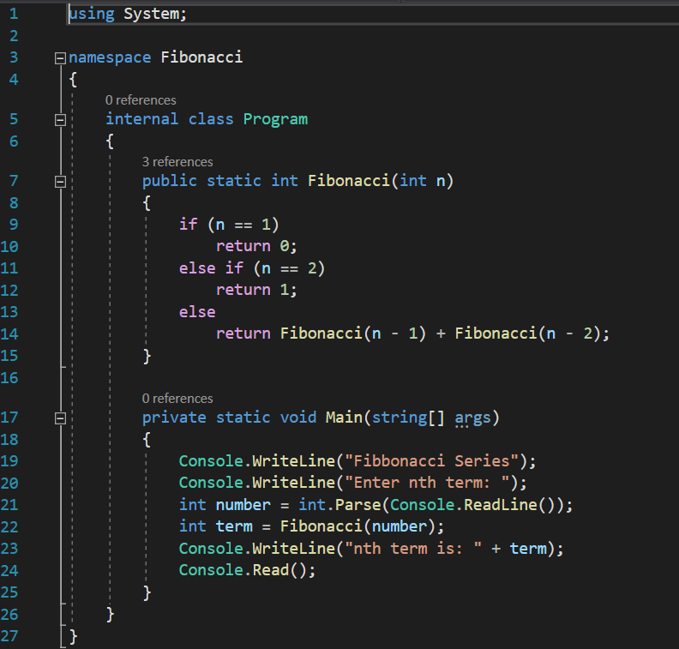

**Output:**

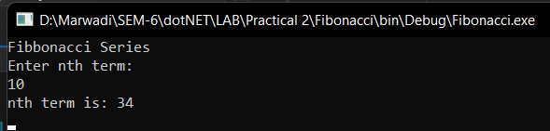

**Program 3: Write a C# program to create a calculator using Switch Case.**

**Code:**

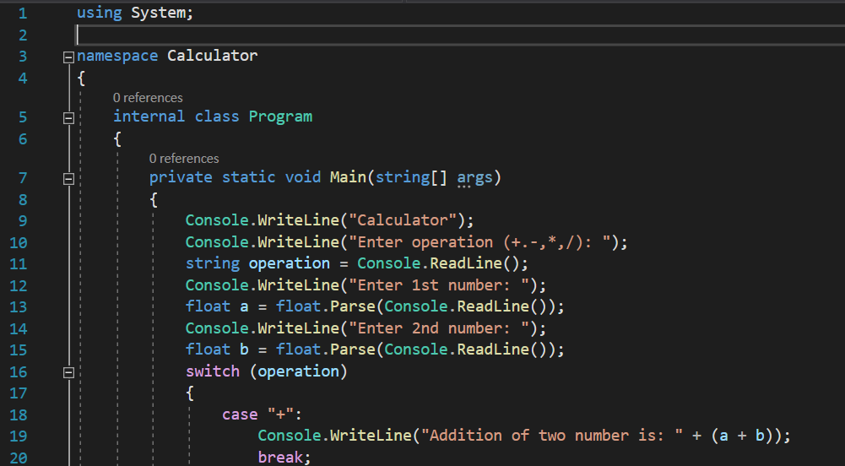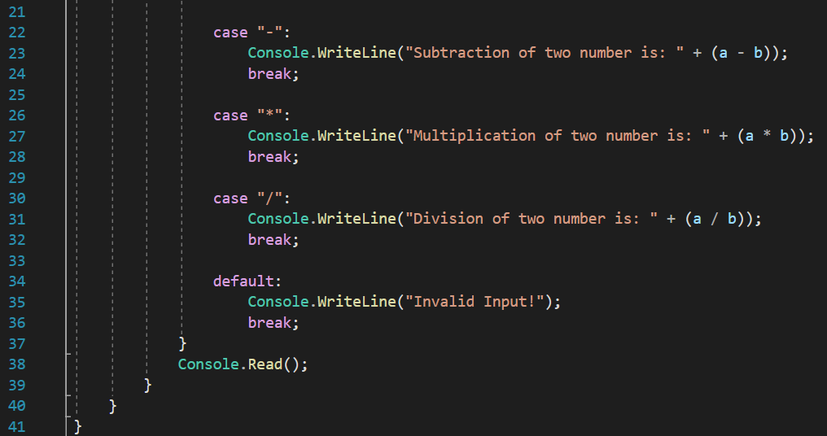

**Output:**

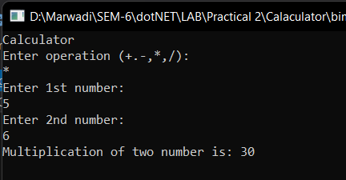

**Program 4: Write a C# Program to print a given array in reverse.**

**Code:**

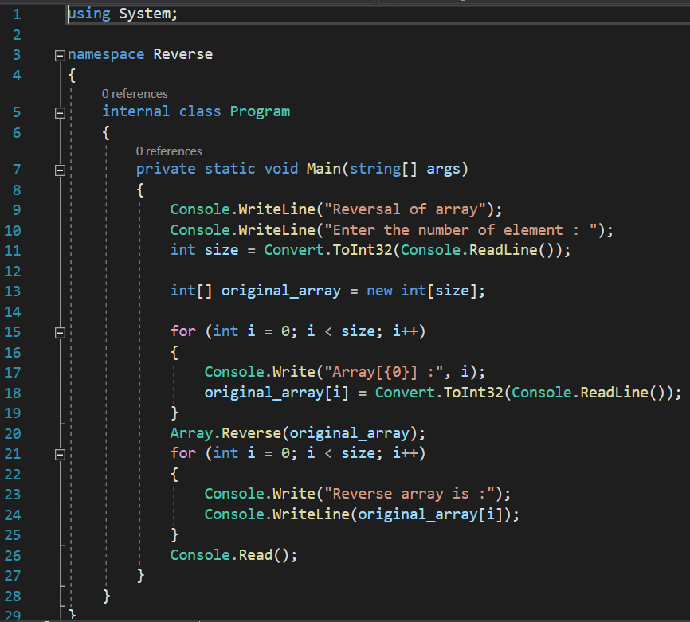

**Output:**

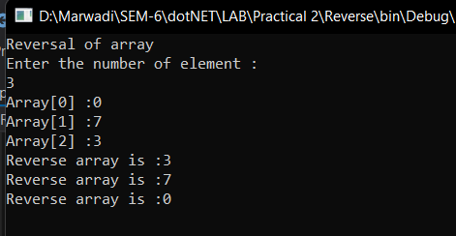

**Program 5: Create a simple C# code for the following:**

**55555**

**4444**

**333**

**22**

**1**

**Code:**

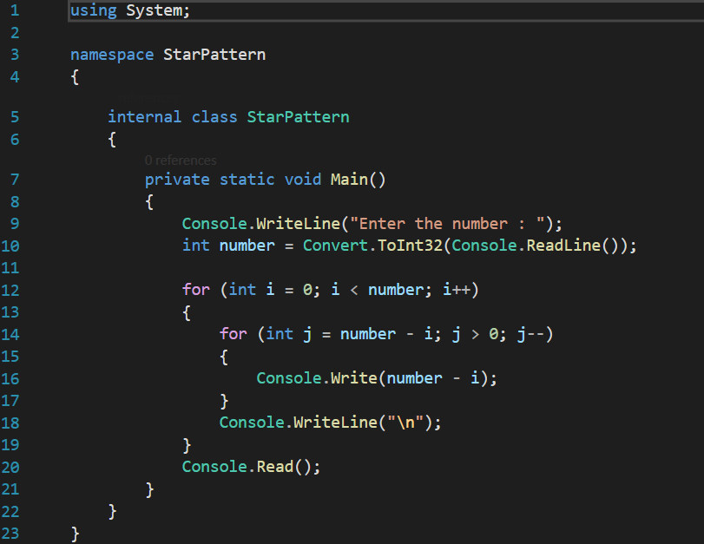

**Output:**

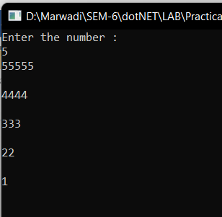

**LAB - 3**

**Program 1: Write a C# program find area of Circle, Rectangle and Square using Polymorphism.**

**Code:**

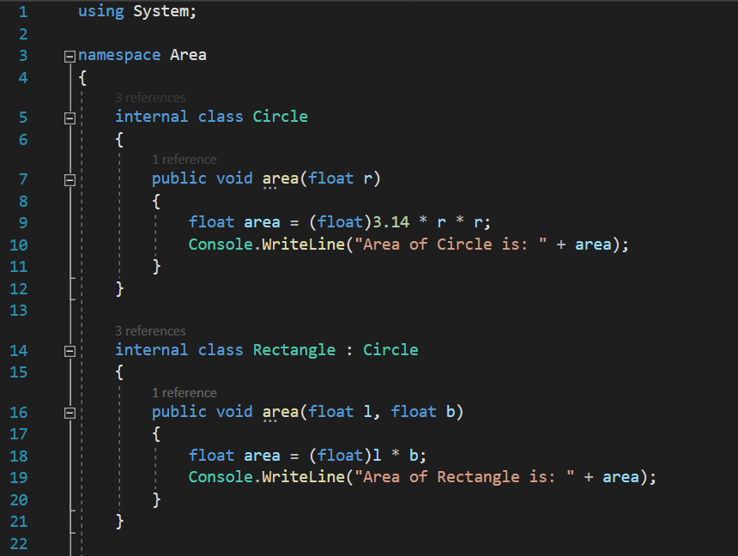

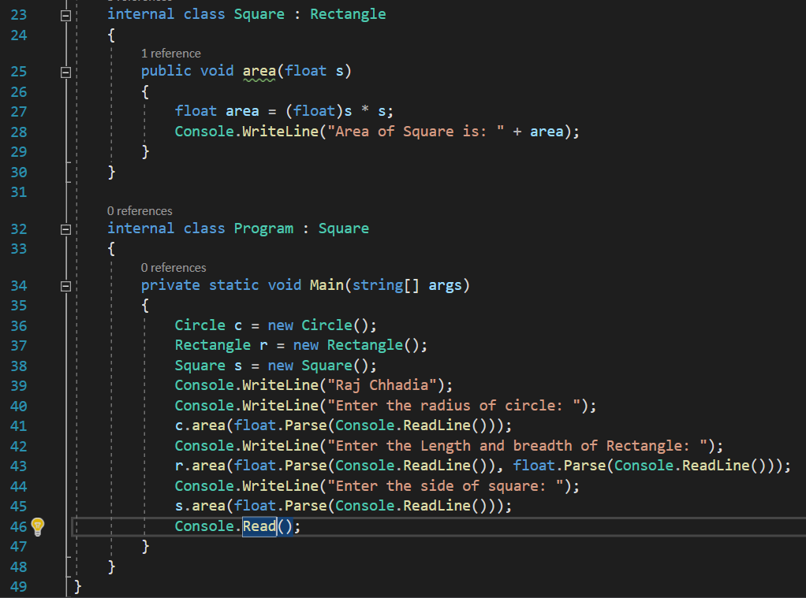

**Output:**

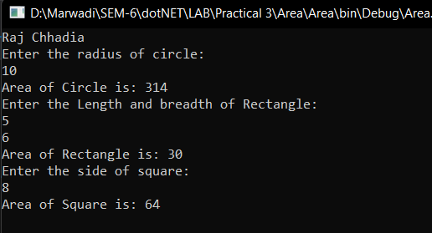

**Program 2: Consider a class Information that has data members as Name, Surname and Contact number. Let Employee and Student class inherits Information class with its own other information such as Students Semester or Employee Salary. Implement a system using Method Overriding to take input from the user for all the information and display proper output.**

**Code:**

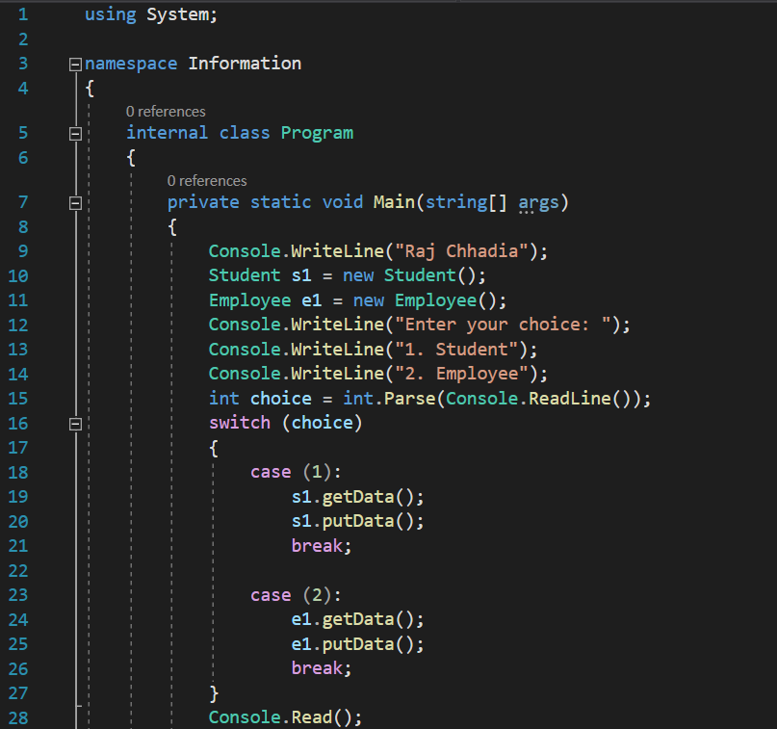

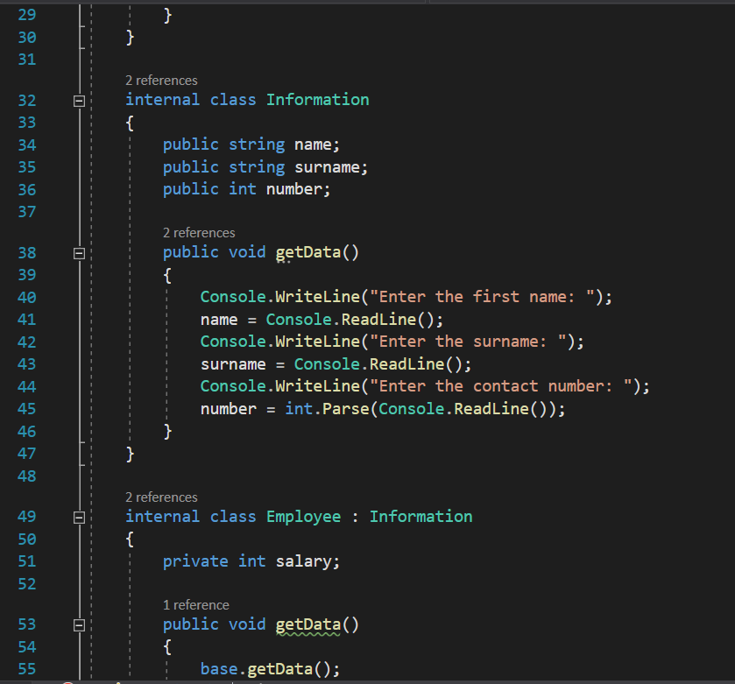

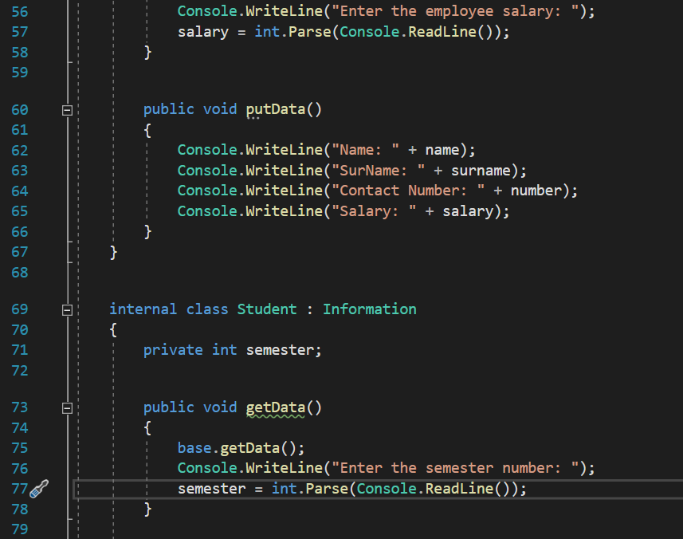

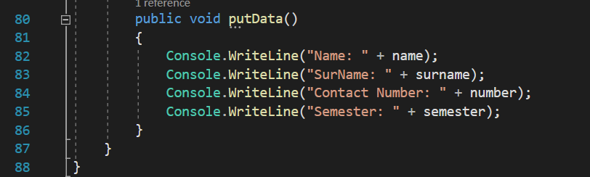

**Output:**

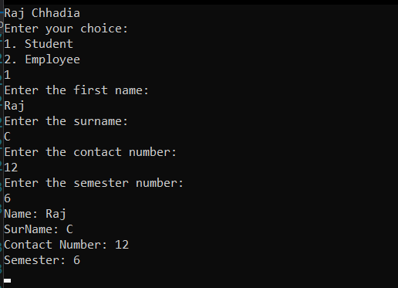

**Program 3: Consider a class Apartment that has data members as Apartment number and balcony type. Implement a system that has 3 classes as 1bhk,2bhk and 3bhk such that it does not allow to create any other classes above 3bhk. Also implement inheritance in such a way that 1bhk will have Rectangular Balcony and all other flats have Rounded Balcony (Use Sealed Class).**

**Code:**

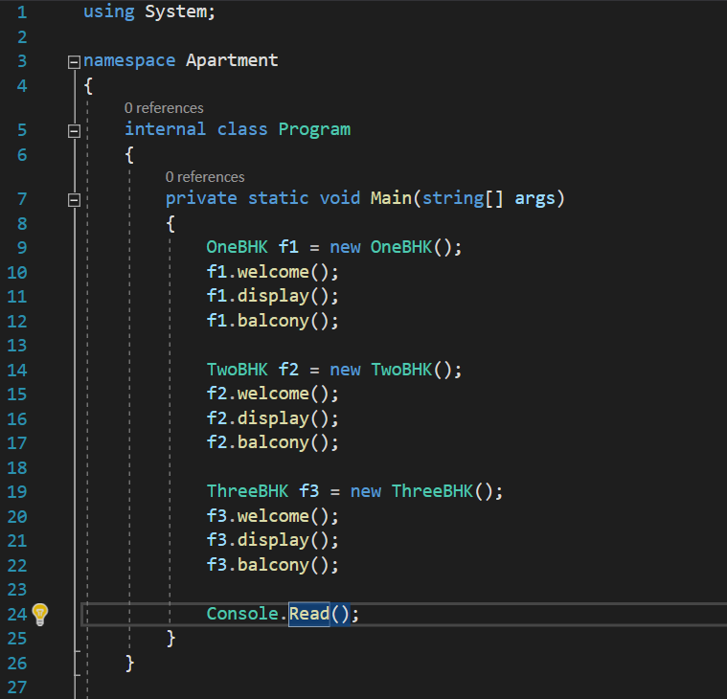

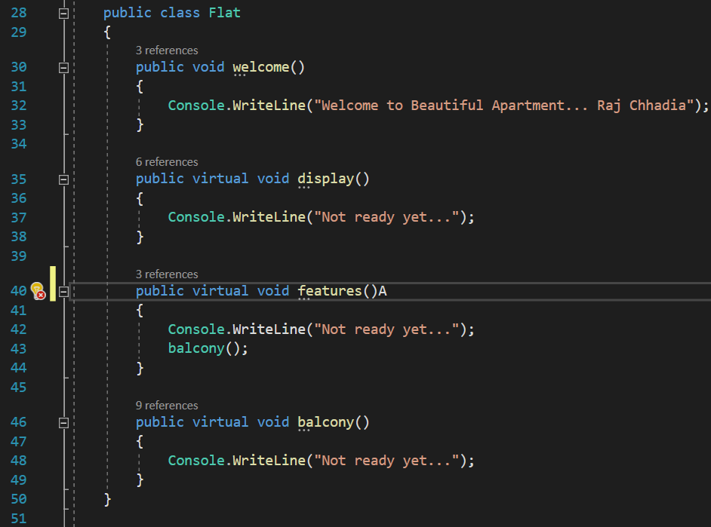

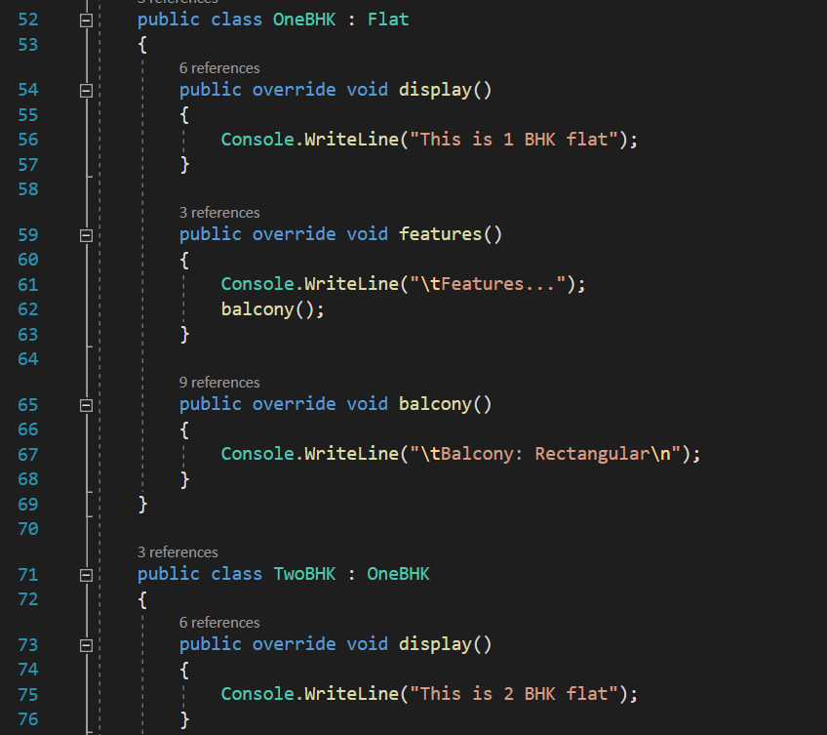

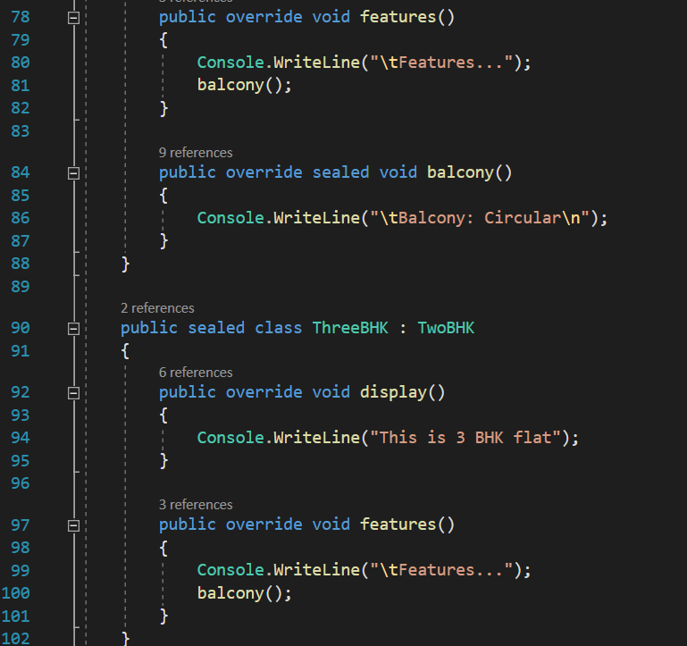

**Output:**

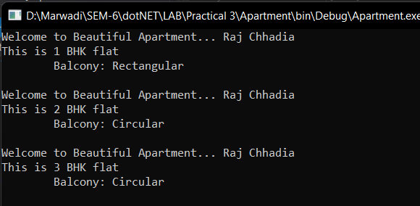

**LAB - 4**

**Program 1: Apply Interface to find the area of Square, Rectangle and Circle. Display proper output.**

**Code:**

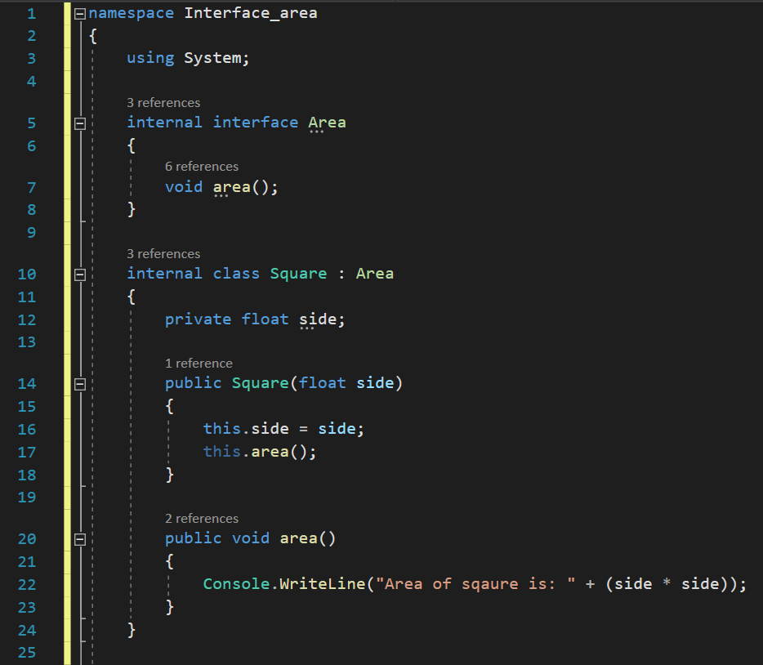

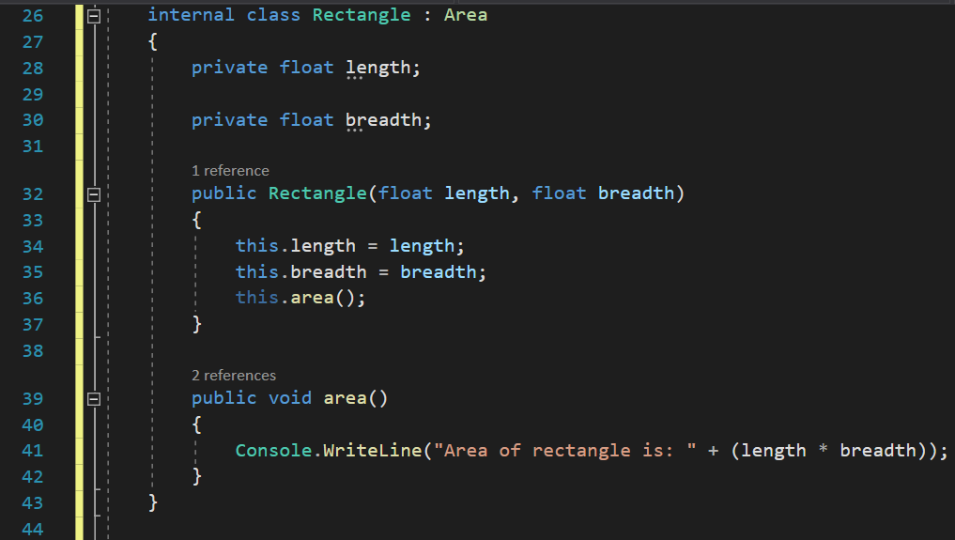

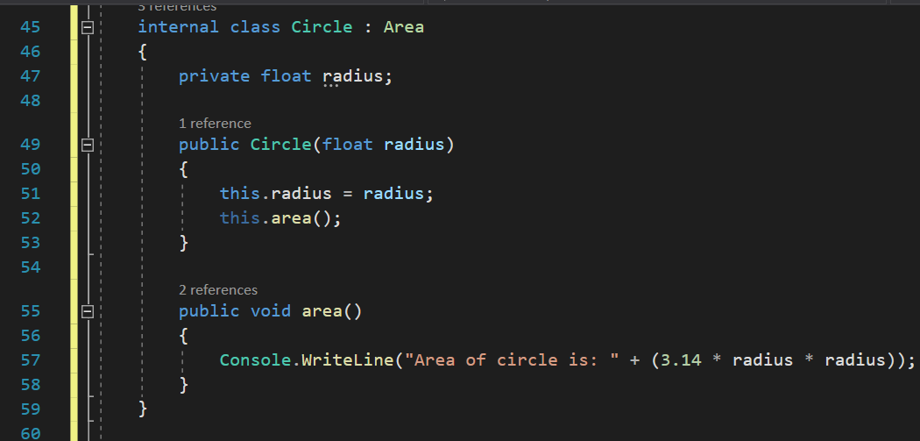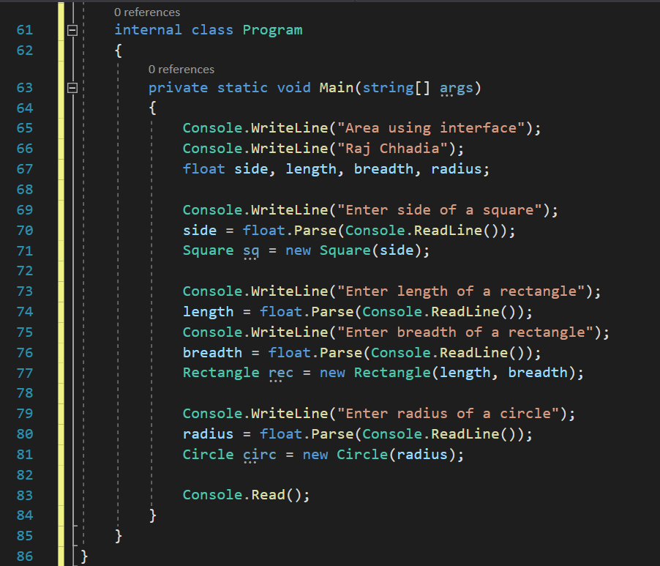

**Output:**

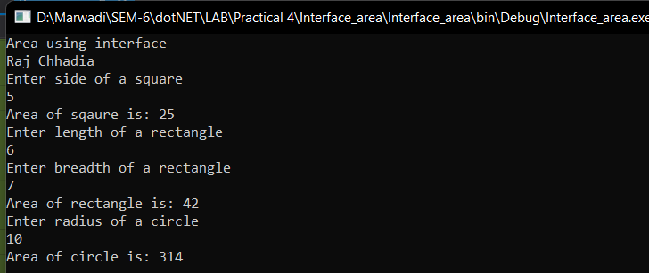

**Program 2: Create two interfaces Icredit and Idebit with methods deposit and withdraw respectively. Create a class Account that inherits interface such that it provides the functionality of Crediting some amount and withdrawing some amount. Use Proper Variables and display output accordingly.**

**Code:**

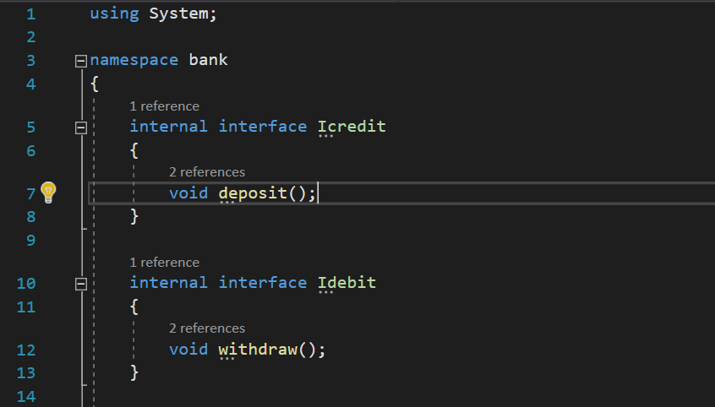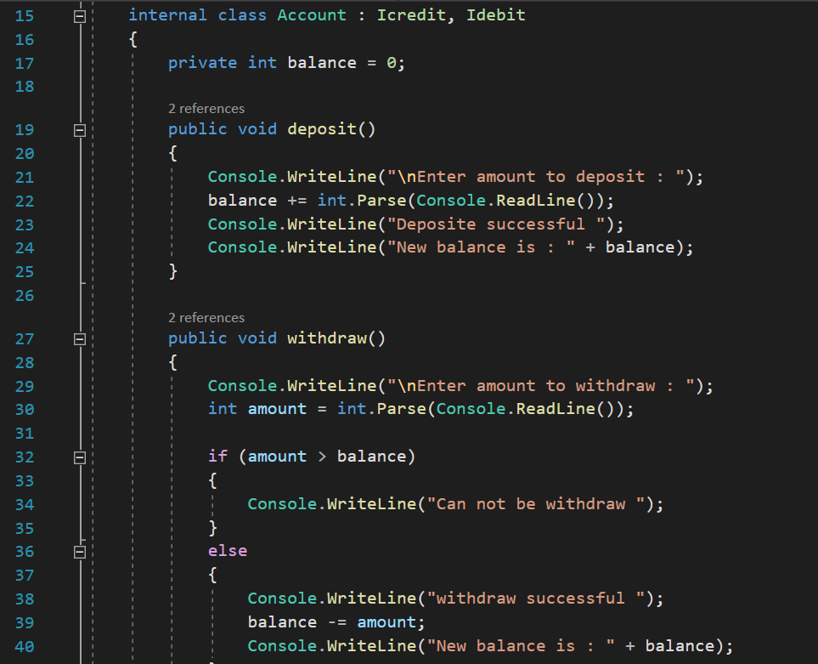

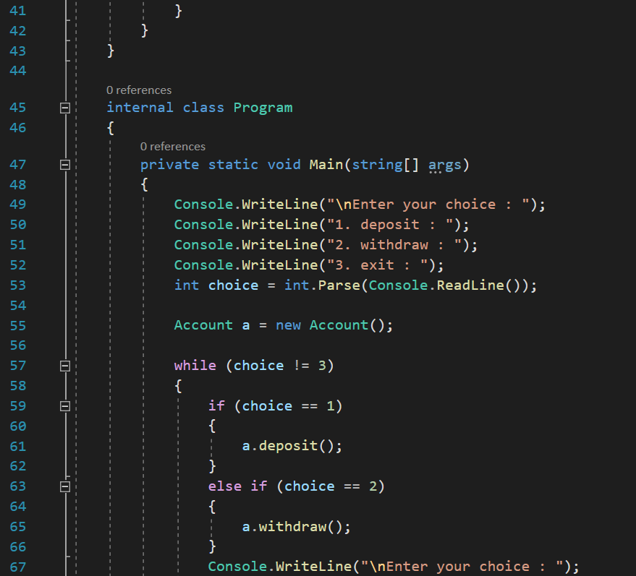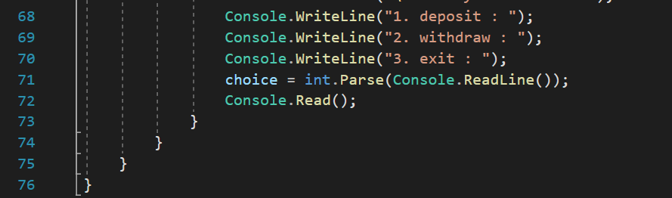

**Output:**

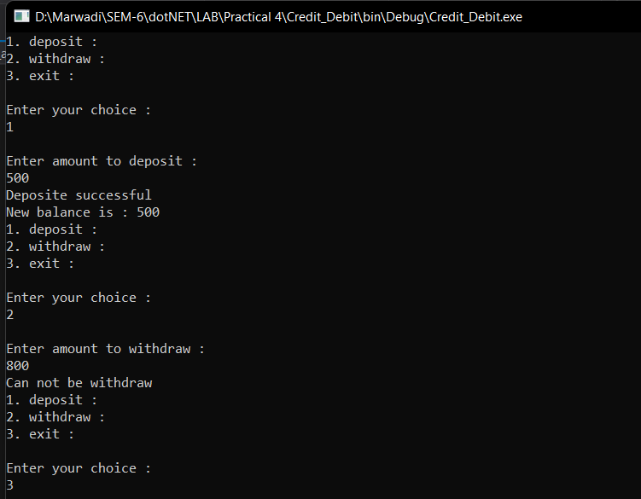

**Program 3** **Demonstrate a calculator using delegate**

**Code:**

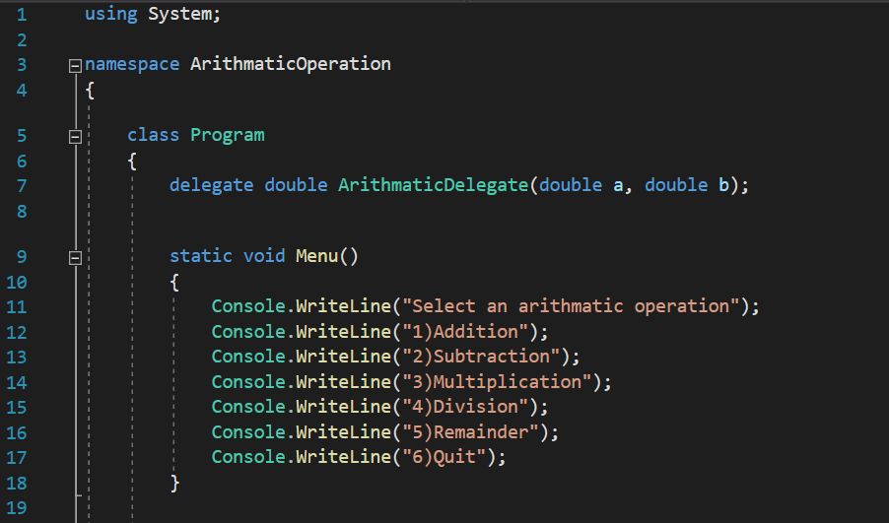

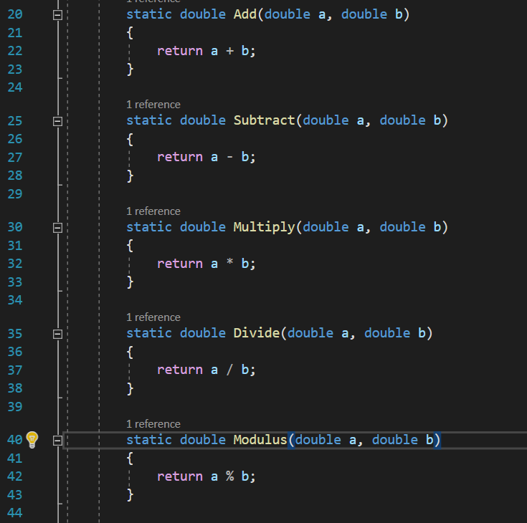

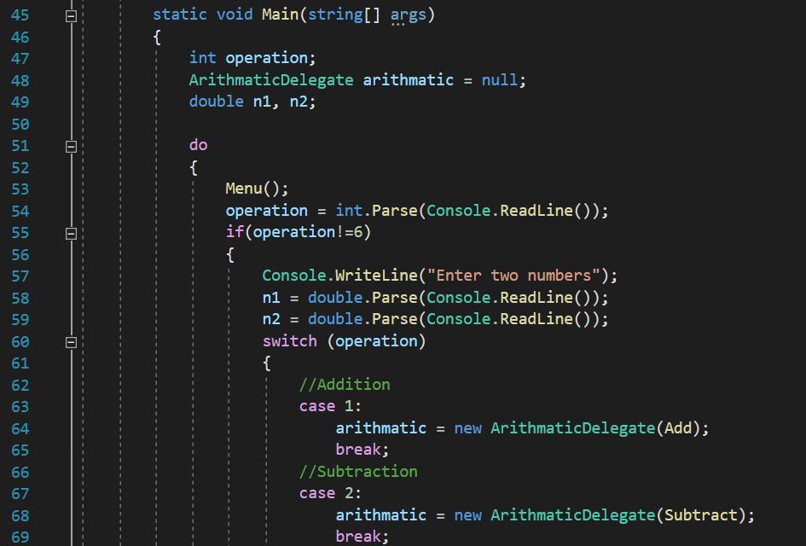

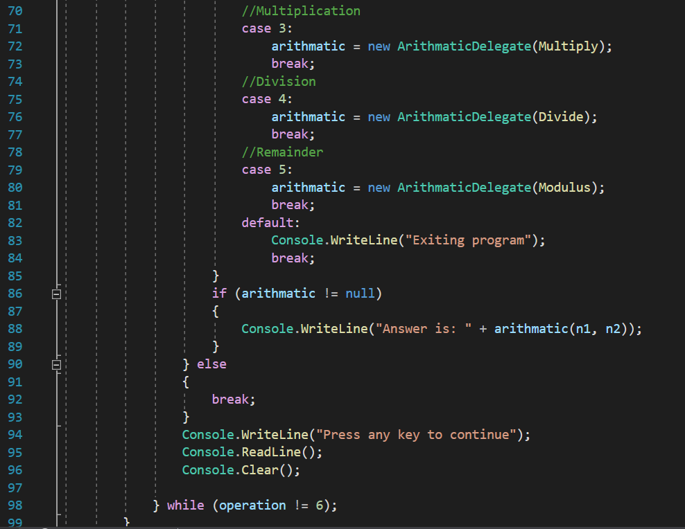

**Output:**

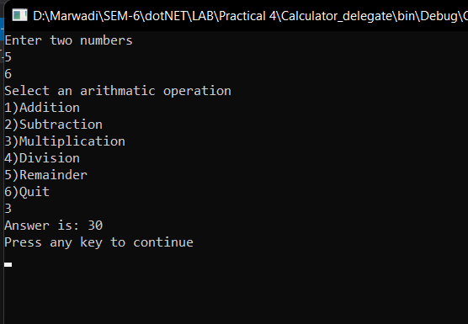

**LAB - 5**

**Program 1: Write a C# Console based application to create following table using ADO. Net.**

**Code:**

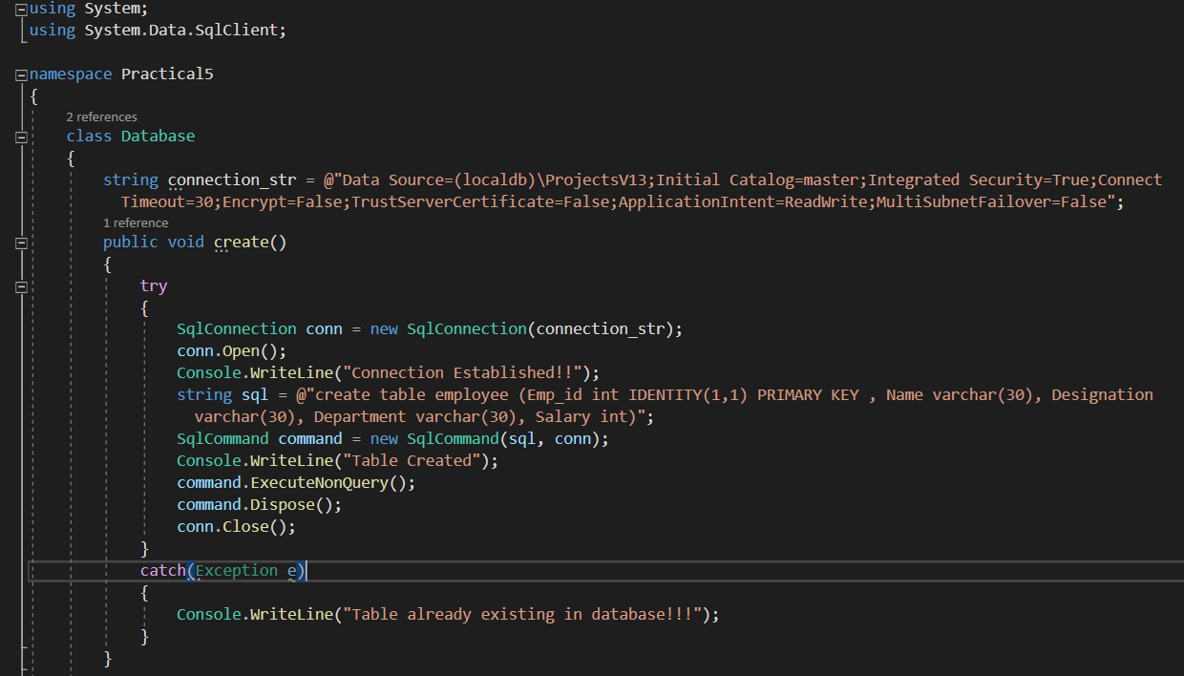

**Output:**

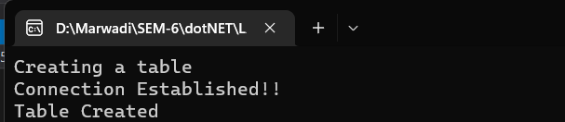

**Program 2: Write a C# Console based application to display all the records of a table.**

**Emp_id Name Designation Department Salary**

**1 Raj Manager Sales 35000**

**2 Priya Manager HR 30000**

**3 Manoj Driver Transport 15000**

**4 Aakash Executive Finance 85000**

**Code:**

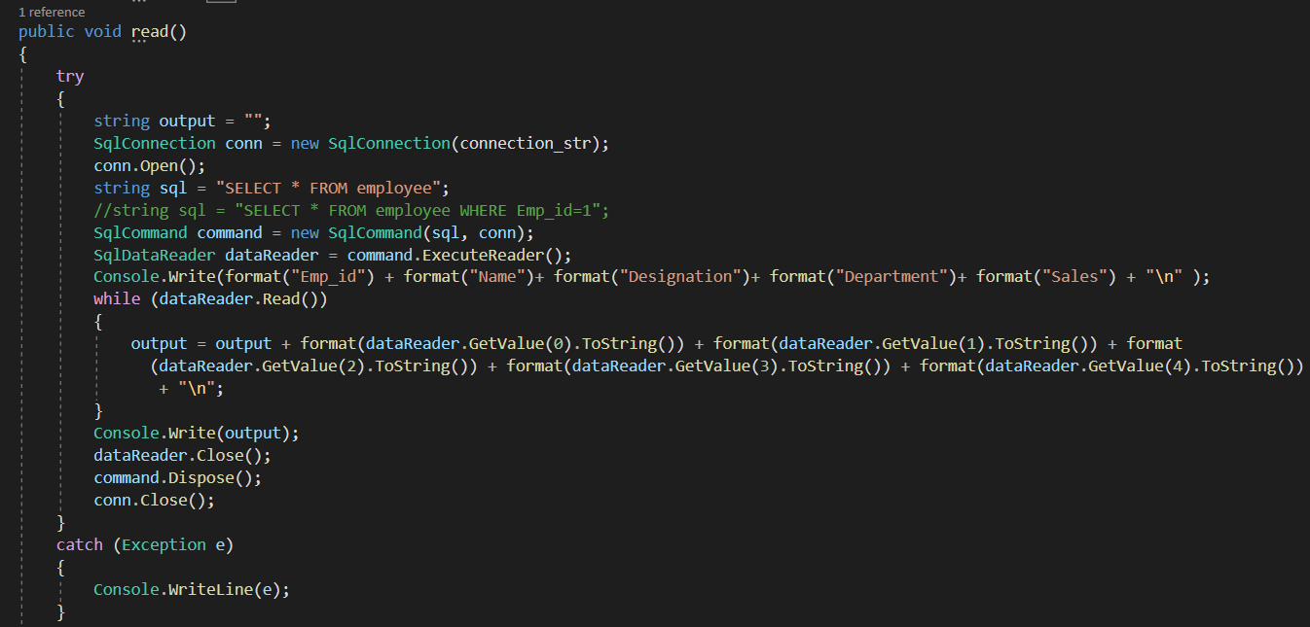

**Output:**

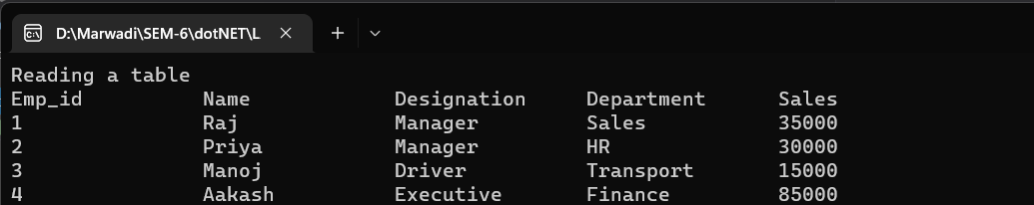

**LAB - 6**

**Program 1: Write a C# Console based application to implement a functionality to insert a new record in the table**

**Code:**

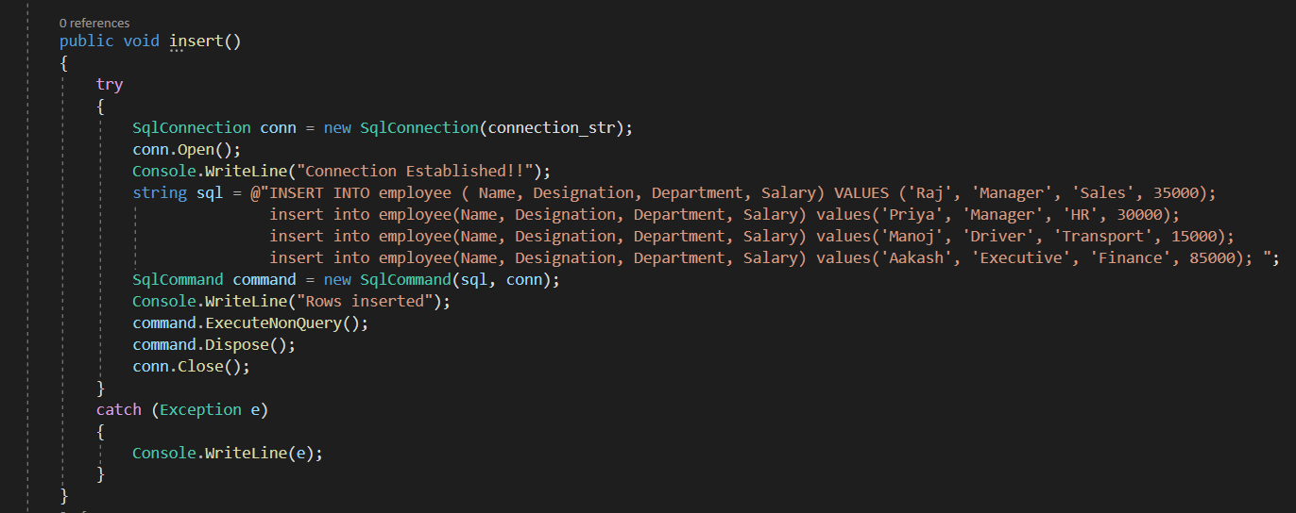

**Output:**

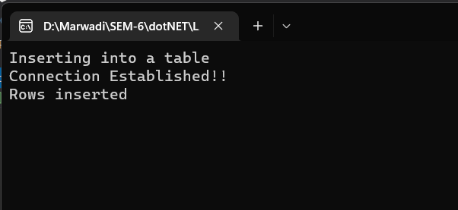

**Program 2: Write a C# Console based application to implement a functionality to display specific record from the table**

**Code:**

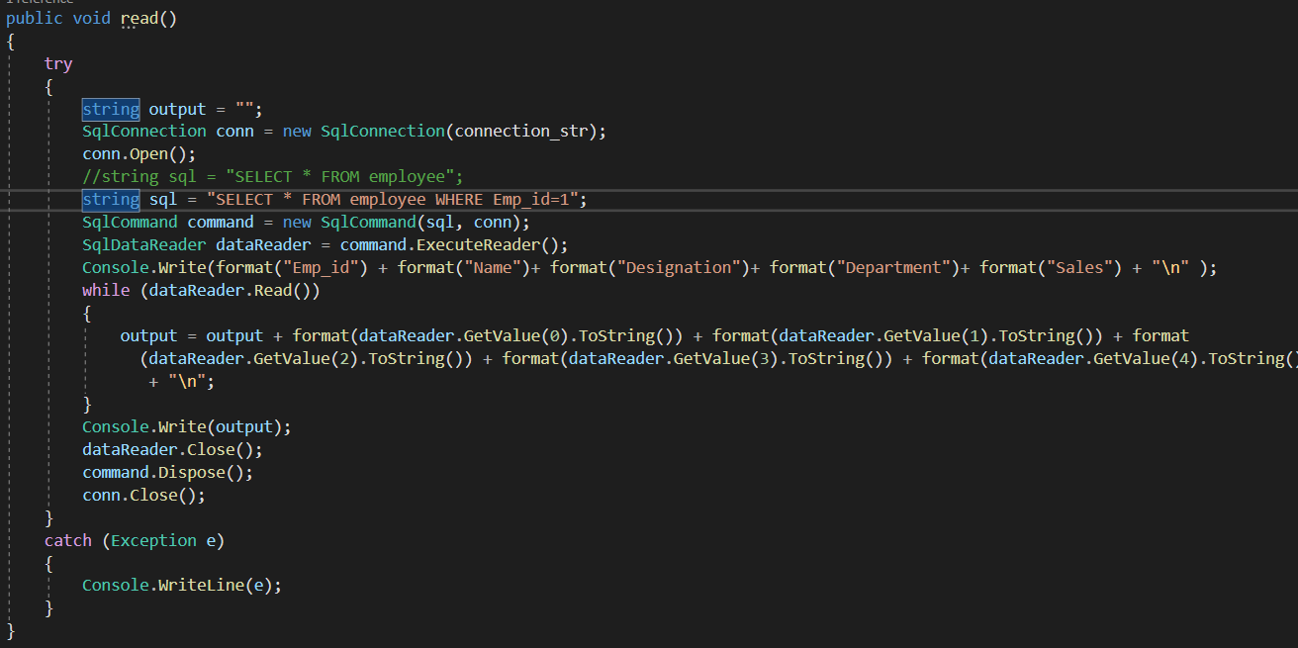

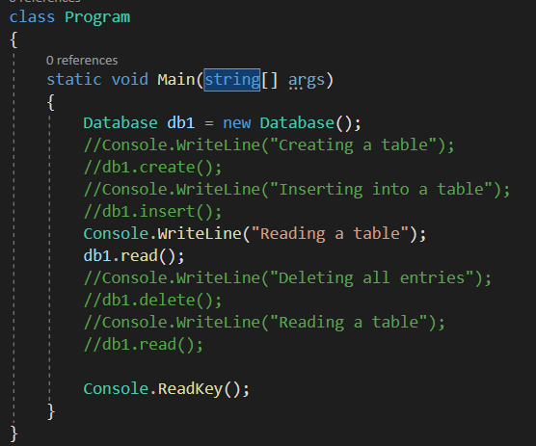

**Output:**

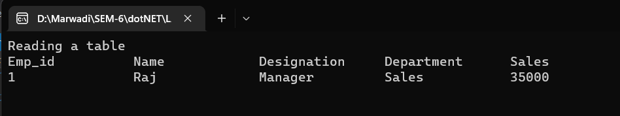

**LAB - 7**

**Program 1: Create a Simple Calculator using Windows Forms.**

**Code:**

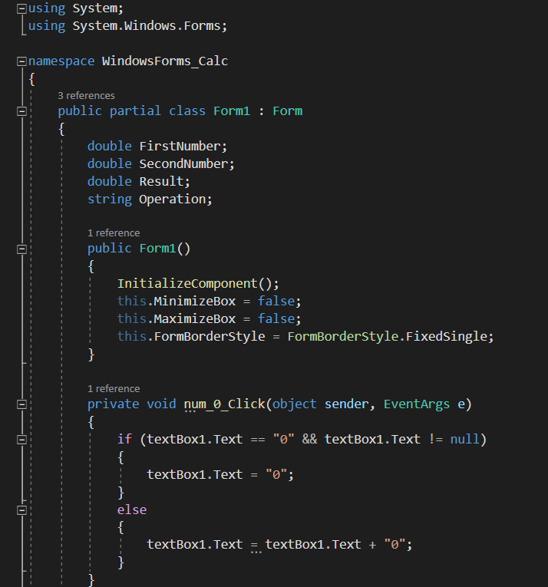

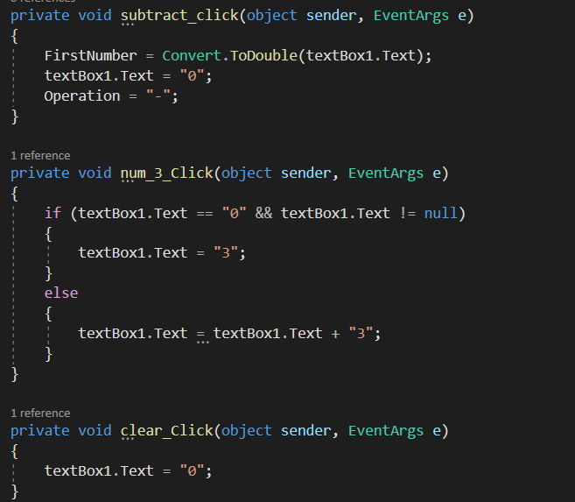

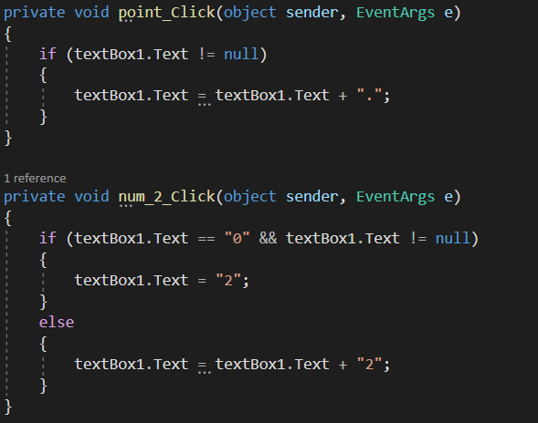

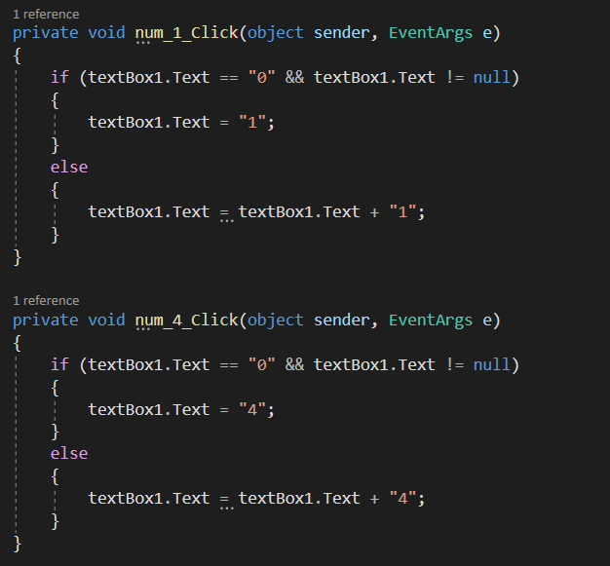

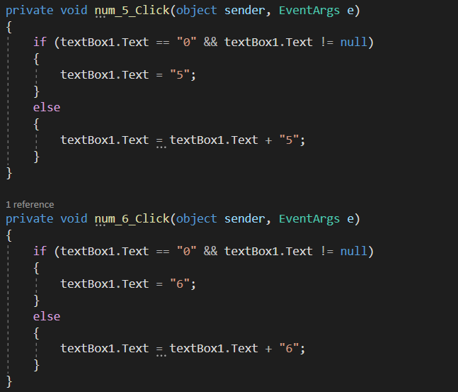

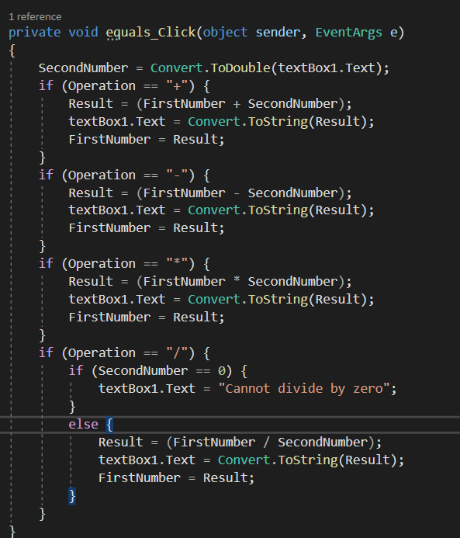

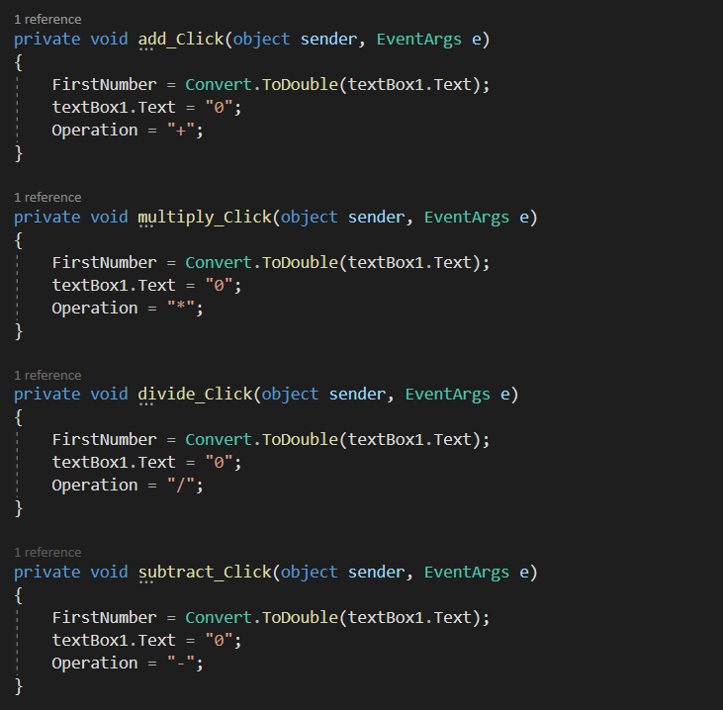

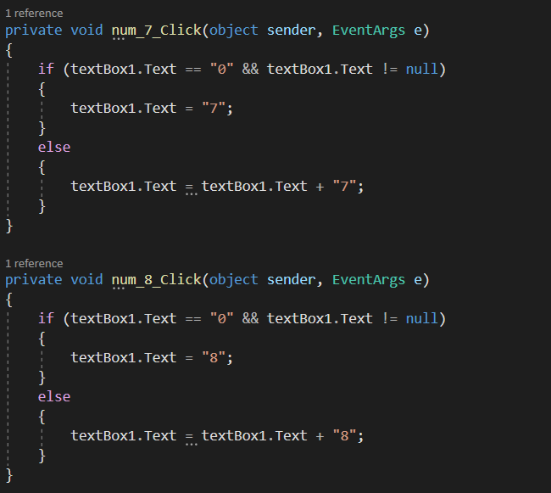

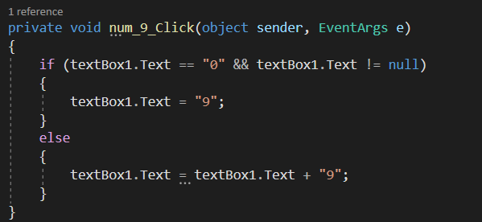

**Output:**

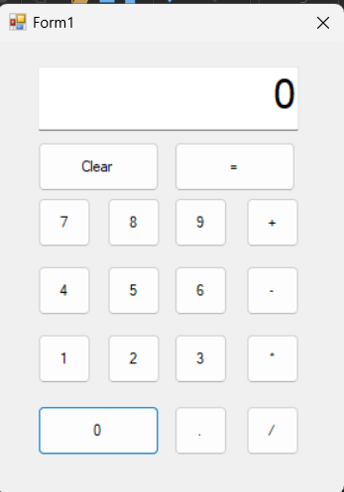

**Program 2: Create a Windows Forms that will change the background color, forecolor and styling of the given text**

**Code:**

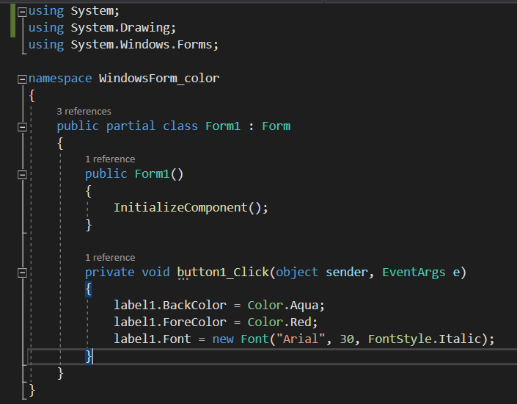

**Output:**

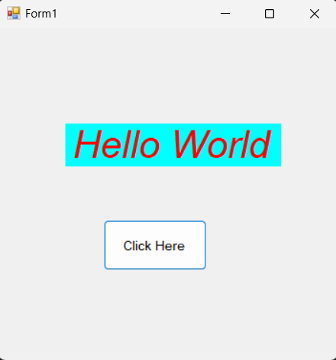

**LAB - 8**

**Program 1: Create a Windows Form that will move the data from one tool to other tool (Usage of ComboBox and ListBox)**

**Code:**

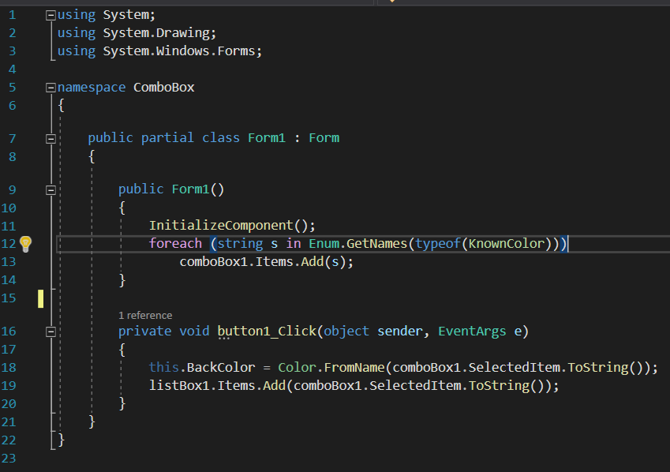

**Output:**

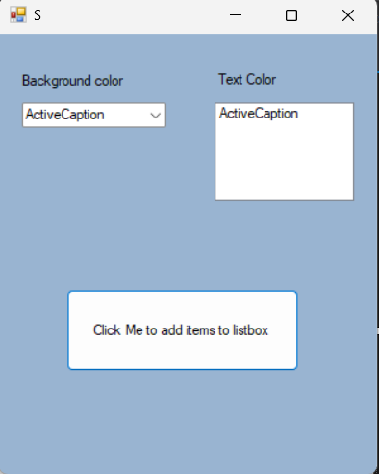

**Program 2: Create a GUI for the following: Consider textbox(txt1) for Full Name, textbox(txt2) for enrolment, textbox(txt3) for email, textbox(txt4) for mobile, combobox(cmb1) for Semester, radiobutton(rd1,rd2) for Gender and datetimepicker(dtp1) for birthdate and button(btn1). Write backend code for taking input of each and display all values in pop-up box with proper message on button (btn1) click.**

**Code:**

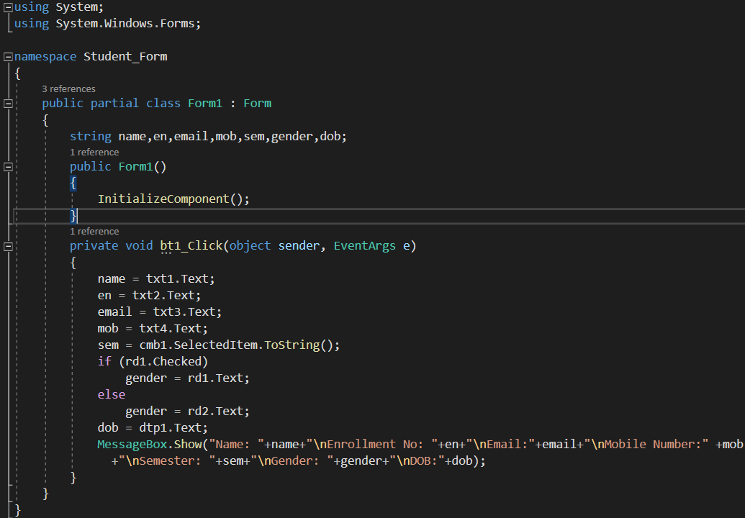

**Output:**

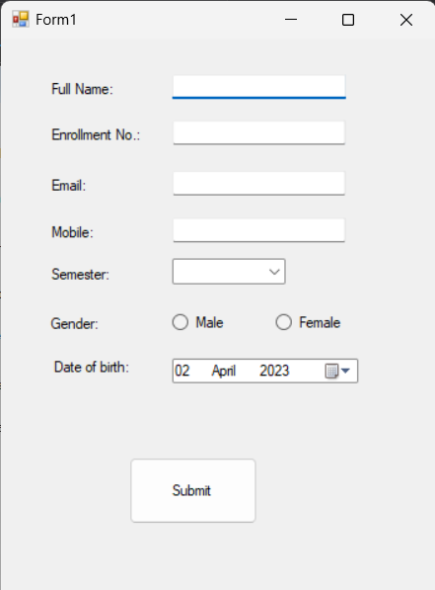

**LAB - 9**

**Program 1: Create a GUI for the following: Consider textbox(txt1) for Full Name, textbox(txt2) for enrolment, textbox(txt3) for email, textbox(txt4) for mobile, textArea(txtarea1) for Address, textbox(txt5) for City, combobox(cmb1) for Semester, radiobutton(rd1,rd2) for Gender and datetimepicker(dtp1) for birthdate, checkbox(ck1) for Agree to Register and button(btn1). Write backend code for taking input of each control and if Agree checkbox is checked, then store all these data in the database. Show Pop-Up message: “Registration Successful”.**

**Code:**

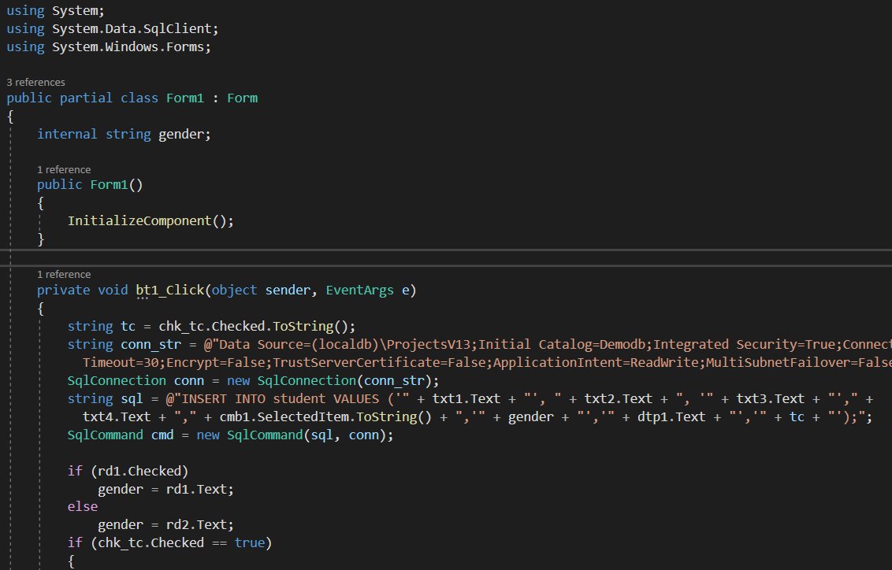

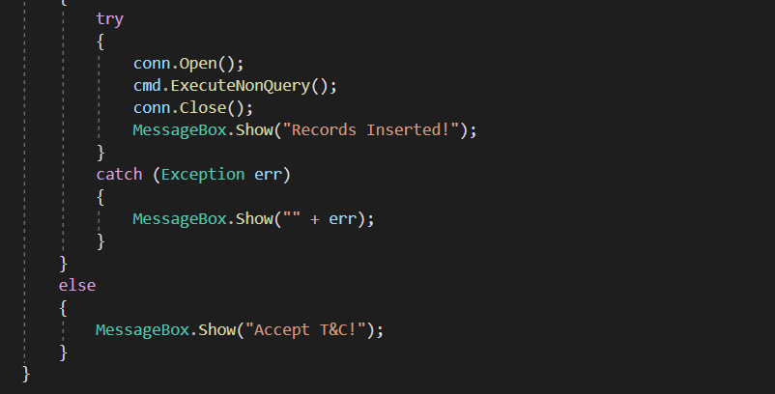

**Output:**

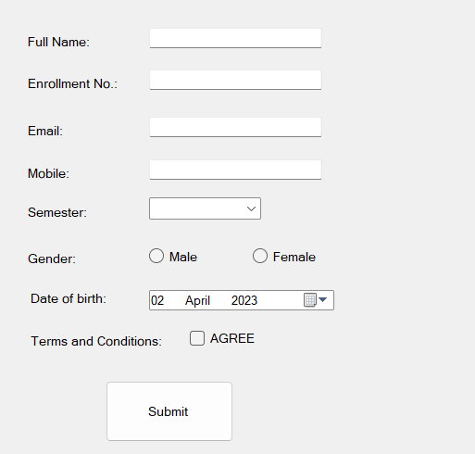

**LAB - 10**

**Program 1: Write a Windows based application to create following table using ADO. Net.**

**Code:**



**Output:**



**Program 2: Write a C# Windows based application to display all the records of a table.**

**Code:**

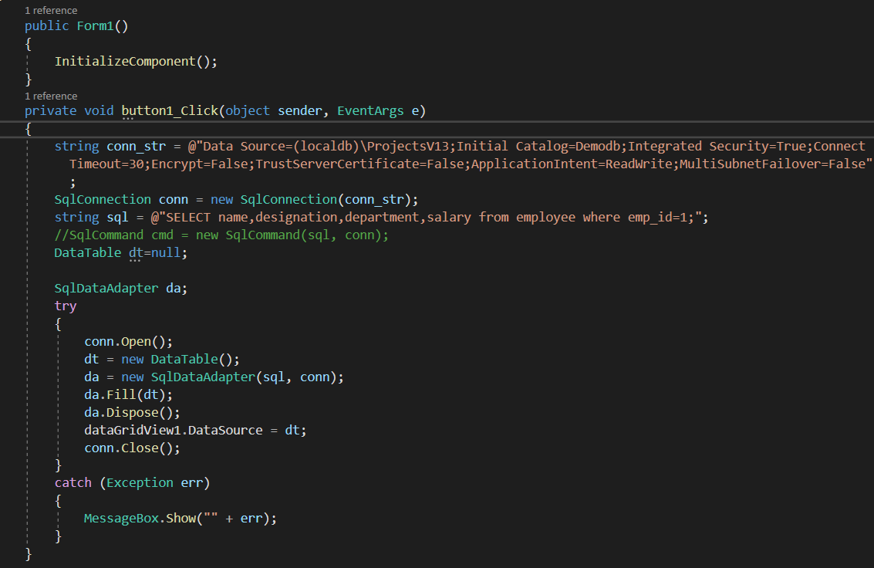

**Output:**

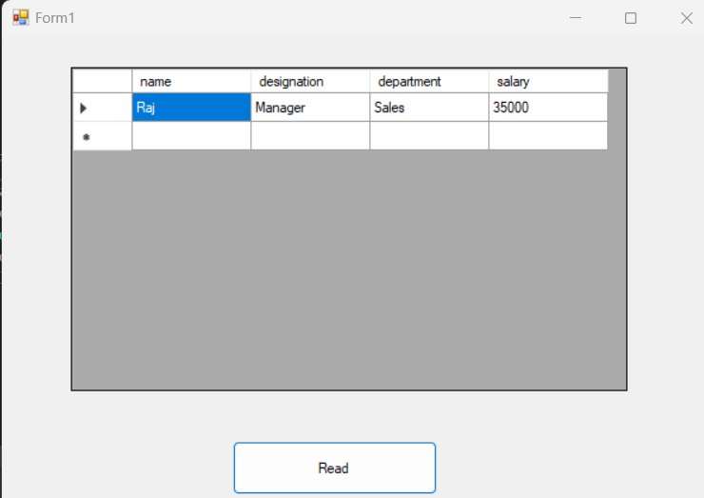

**LAB - 11**

**Program 1: Write a C# Windows based application to implement a functionality to insert a new record in the table**

**Code:**

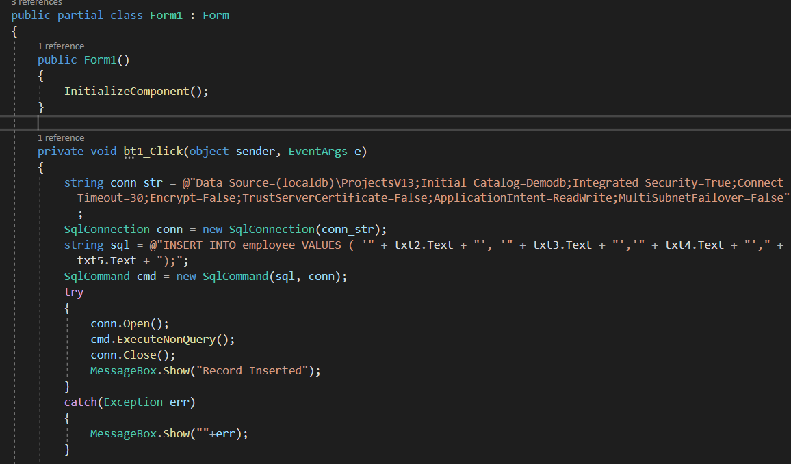

**Output:**

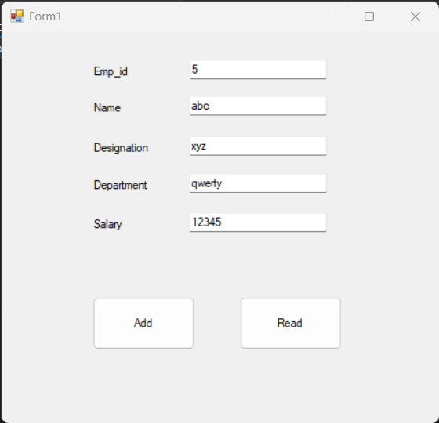

**Program 2: Write a C# Windows based application to implement a functionality to display specific record from the table**

**Code:**

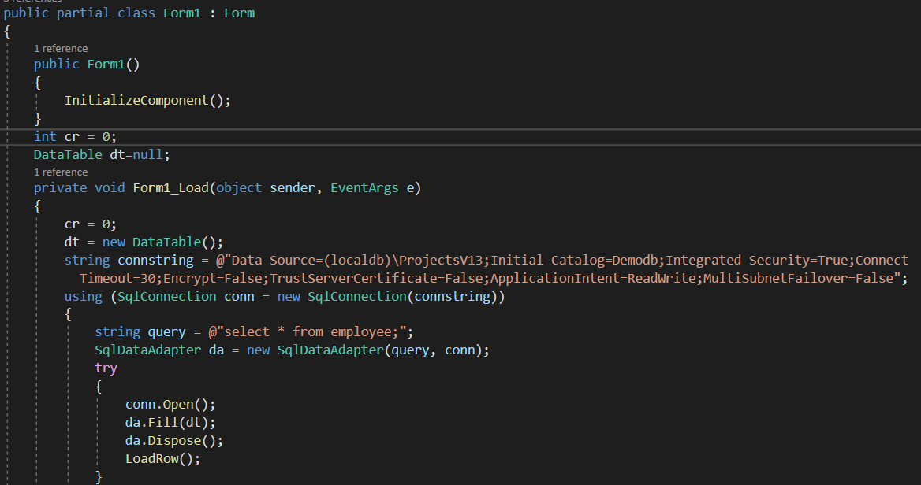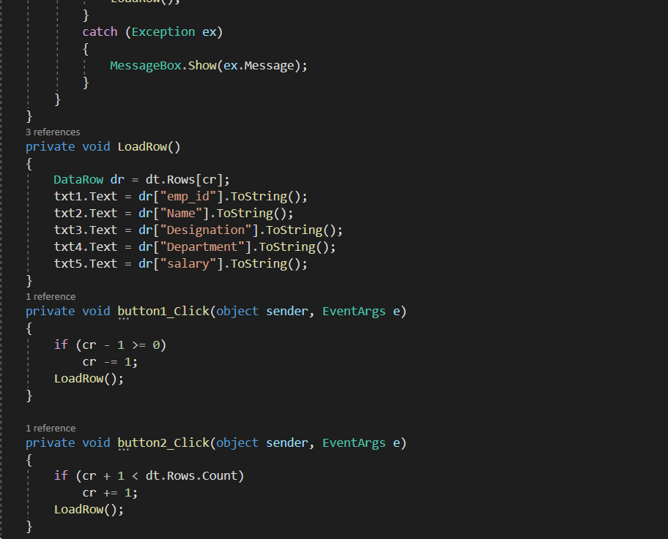

**Output:**

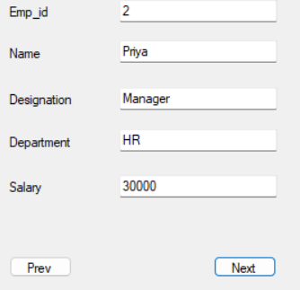

**LAB - 12**

**Program 1: Write a C# Windows based application to implement a functionality to insert a new record in the table**

**Code:**

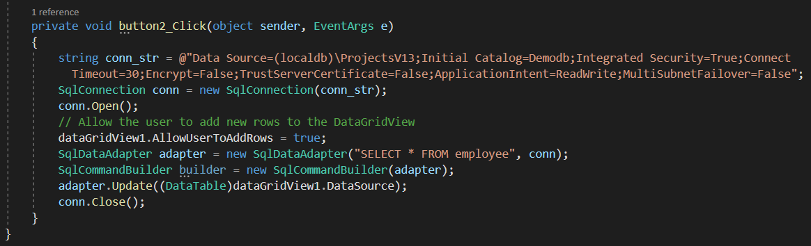

**Output:**

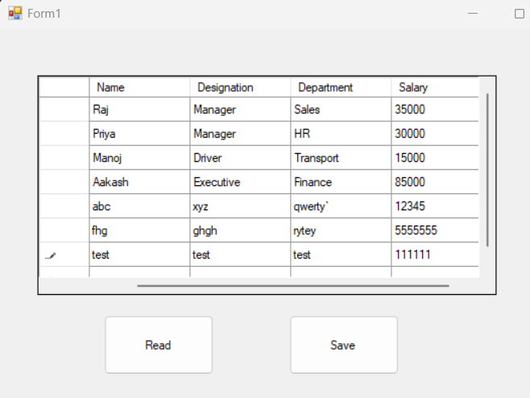

**Program 2: Write a C# Windows based application to implement a functionality to display specific record from the table**

**Code:**

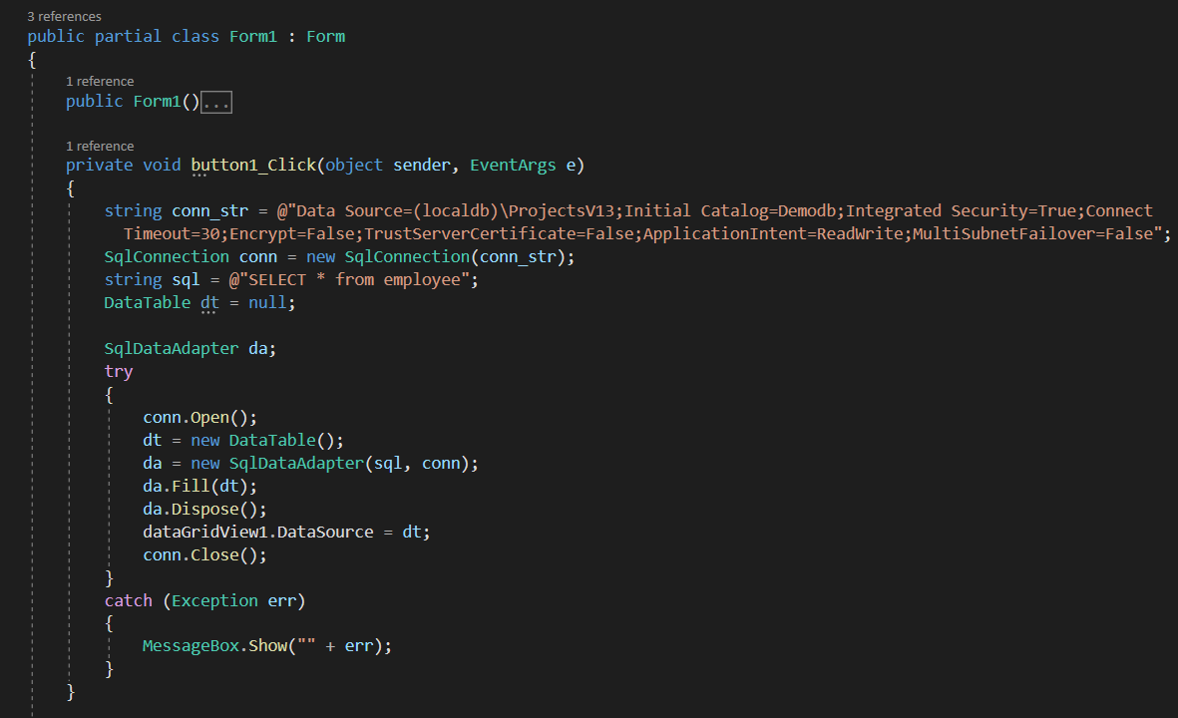

**Output:**

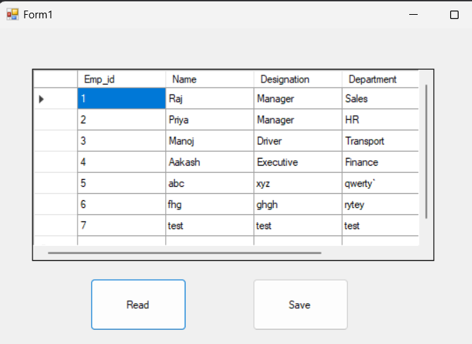

**LAB - 13**

**Program 1: Write a C# code to generate 3 different lines of different colors**

**Code:**

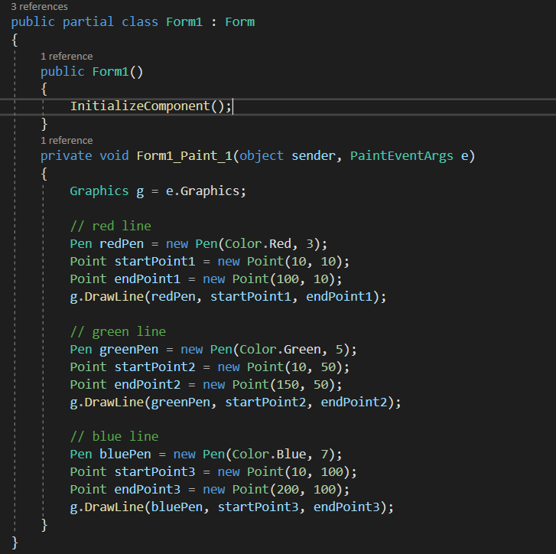

**Output:**

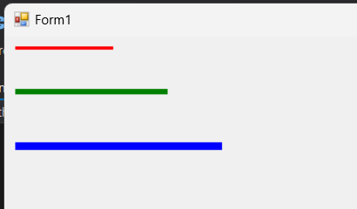

**Program 2: Write a C# code to generate 4 different lines of Multicolor Rectangle**

**Code:**

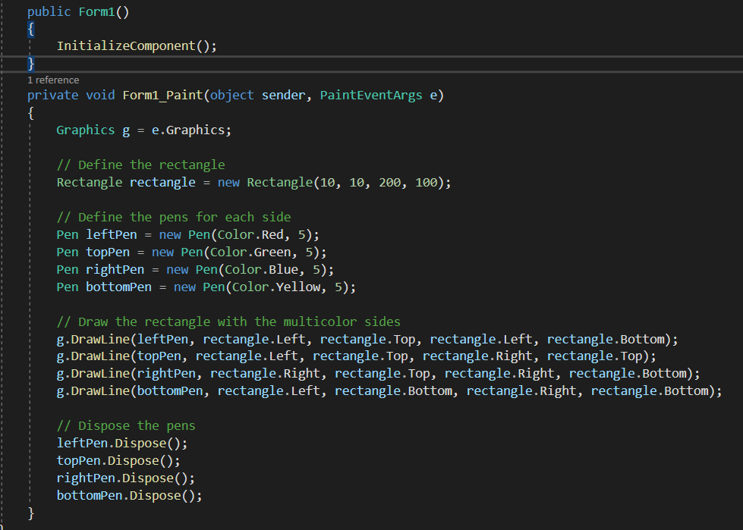

**Output:**

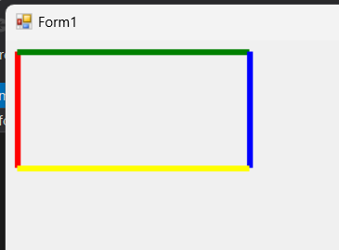

**Program 3: Write a C# code to generate 2 ellipses on a windows form.**

**Code:**

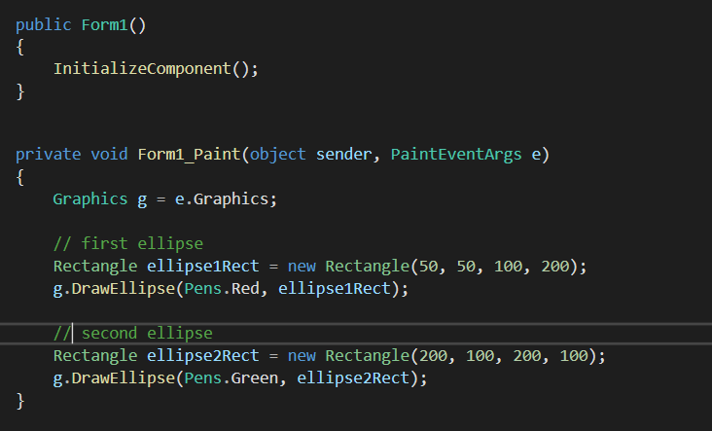

**Output:**

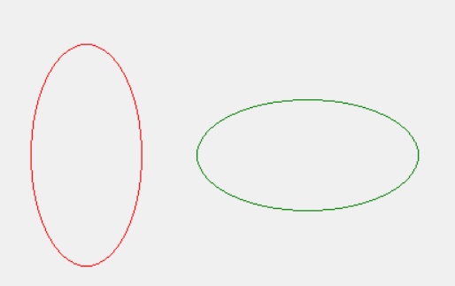

**LAB - 14**

**Program 1: Write XAML code for the following: Consider textbox(txt1) for First Number, textbox(txt2) for Second Number, textbox(txt3) for Answer, and 4 buttons (btn1,btn2,btn3,btn4) for Addition, Subtraction, Multiplication and Division respectively. Write backend code for taking input of 2 numbers and display relevant output as per button click**

**Code:**

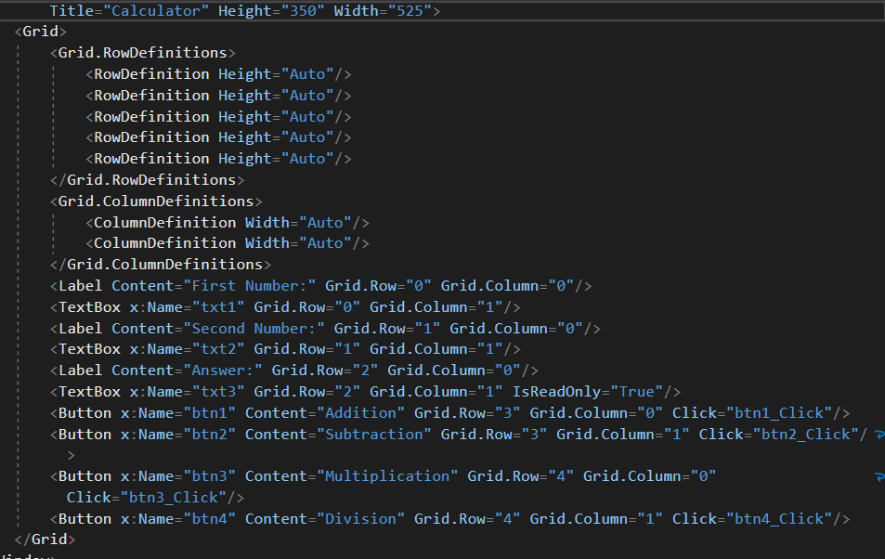

**Output:**

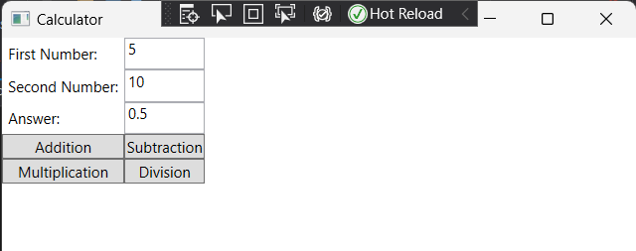

**Program 2: Write XAML code for the following: Consider textbox(txt1) for Full Name, textbox(txt2) for enrolment, textbox(txt3) for email, textbox(txt4) for mobile, combobox(cmb1) for Semester, radiobutton(rd1,rd2) for Gender and datetimepicker(dtp1) for birthdate and button(btn1). Write backend code for taking input of each and display all values in pop-up box with proper message on button (btn1) click.**

**Code:**

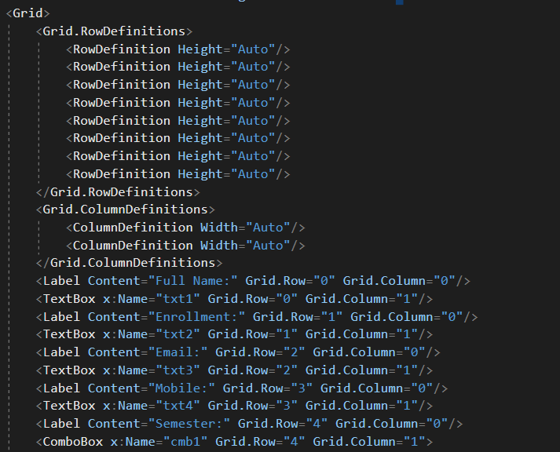

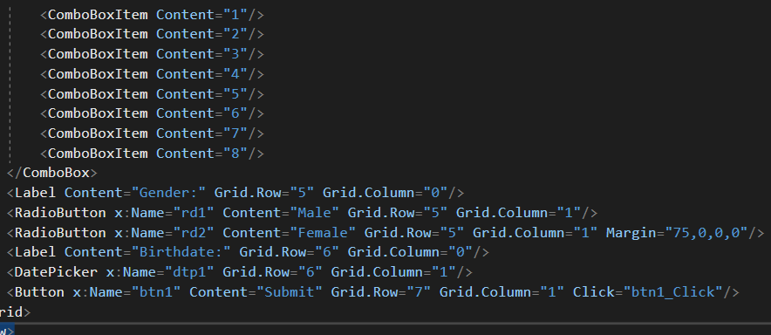

**Output:**

